## **PROJECT TRACK**

## **Project Proposal (To be sent for the approval of the project):**

1. **Title** : Project Title
2. **Abstract** : Tell us what the project is about
3. **Literature Review** : Tell us the all the websites you have used in this project
4. **Details/Steps** : Tell us the steps and the details of project, *circuits if any, diagrams if any, images if any* of the project
5. **Expected Results** : A clip, image or explanation of the how the final prototype wil function
6. **Tools Required** : Required tools for building the project
7. **BOM** : Table of part name, quantity, *price per unit\**, *total price\**, source of buying (link/Store name), *Funding type\*\**

*\* If 3d printer is used fill price per unit as NIL and the total grams of the print in total price*

*\* In price per unit and total price, mention the amount that lab has to pay*

*\*\* Funding type can be self-Funded, Assist-Funded, LAB-Funded (to be filled during review and meet)*

* *Self-Funded : LAB will* ***NOT*** *reimburse the amount of that part. In price per unit and total price, mention 0*
* *Assist-Funded : LAB will* ***ONLY*** *reimburse a part of the amount mutually agreed upon. In price per unit and total price, mention the amount that is requested from the lab*
* *LAB-Funded : LAB will* ***FULLY*** *reimburse the amount of that part. In price per unit and total price, mention the full amount*

 **IMPORTANT ❗:**

* ONLY BUY THE PARTS ONCE IT IS APPROVED. THE AMOUNT WILL BE REIMBURSED TO THE TEAM LEADER **IF AND ONLY IF THE PARTS ARE APPROVED**
* THE PARTS AND TOOL FUNDED BY THE LAB ARE **NOT ALLOWED OUTSIDE** THE LAB EVEN AFTER COMPLETION. THE PARTS **MAY BE ALLOWED TEMPORARILY FOR DEVELOPMENT PURPOSES** ONLY AFTER IT IS LOGGED

**UPDATES JOURNAL (To be updated daily):**

1. **Date** : The date you worked on your project
2. **AIM** : The target you were trying to achieve
3. **Updates** : What you have actually achieved with *images or clips if any (recommended to have images)*
4. **Troubleshooting** : Things to keep in mind/ unexpected errors encountered

Example is given below:

SMART POT

**Abstract:** An IoT project based on a smart pot can be a great way to monitor and care for indoor plants. [The smart pot is equipped with sensors that allow you to monitor environmental parameters such as soil moisture and light](https://papers.ssrn.com/sol3/papers.cfm?abstract_id=3562964) levels. [This information can be used to automate the care of houseplants by providing automatic water pumping into plant soil in the right amount, providing adequate Light in dark surroundings,](https://papers.ssrn.com/sol3/papers.cfm?abstract_id=3562964) keeping a log of watered days. [The data collected by the smart pot can be uploaded to the cloud using the internet through Wi-Fi and can be accessed through an android application](https://papers.ssrn.com/sol3/papers.cfm?abstract_id=3562964). This project has the potential to revolutionise the way we care for indoor plants and make it easier for people to maintain healthy plants.

**Literature Review:**

* [**Smart, Self-watering Plant Pot Planter "Flora" by Martin_McMaker - Thingiverse**](https://www.thingiverse.com/thing:4921885)
* [**Silic - o - Hack 2023 Winner Project**](https://www.tinkercad.com/things/dSf4Sr0fjCA?sharecode=Zc1drCgaHbjBibmzNB9_ajDTjG7SfDqKY42qExFL4sY)

### Soil Moisture Diagram

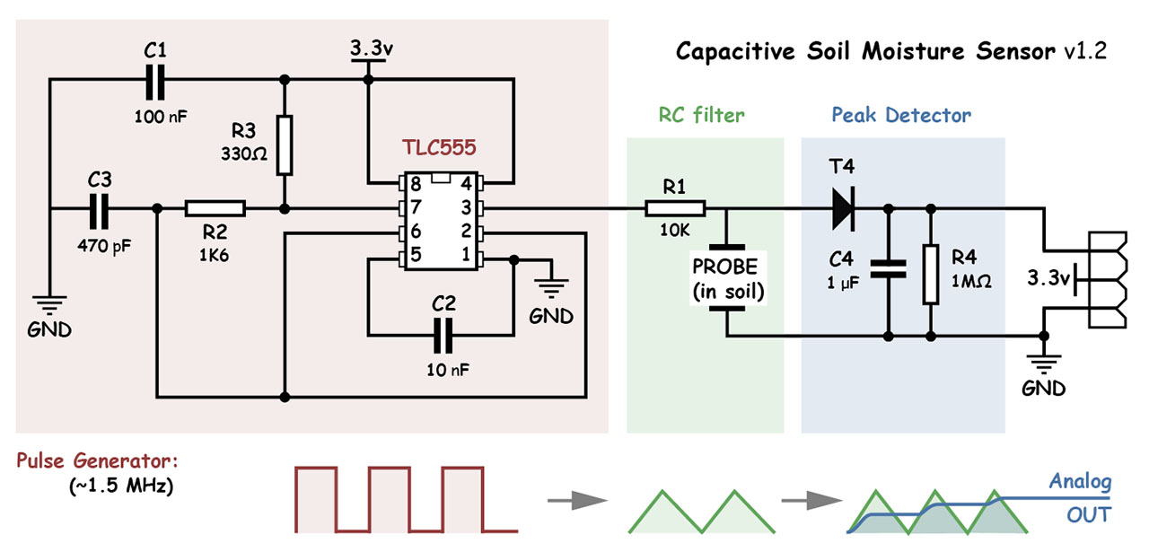

### R365 Water pump diagram

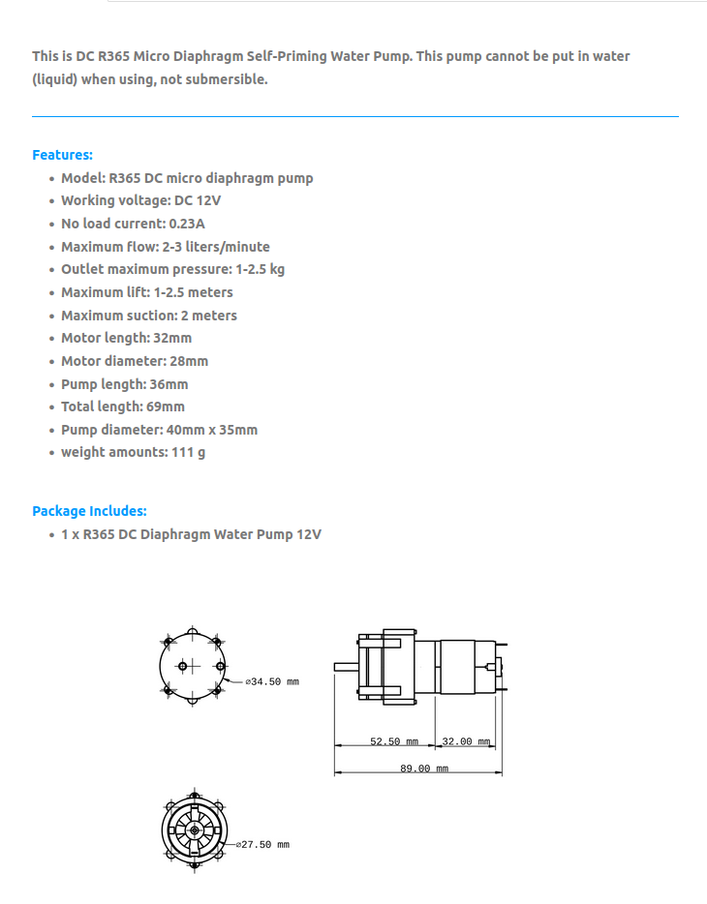

**Procedure:**

* Make an app for getting updates via net
* Upload data to cloud, firebase is ideated as of now
* Water two plant using one MCU independently
* Also tackle the light intensity provided to plant using LEDs

Diagram 1 using esp 32 (one of the pot is LDR)

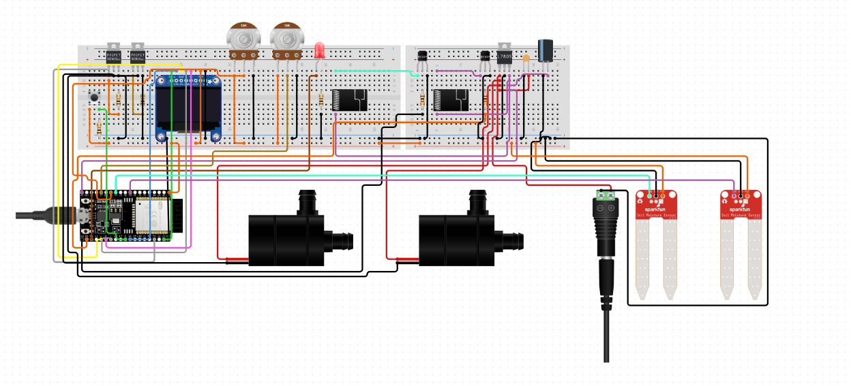

Using Arduino

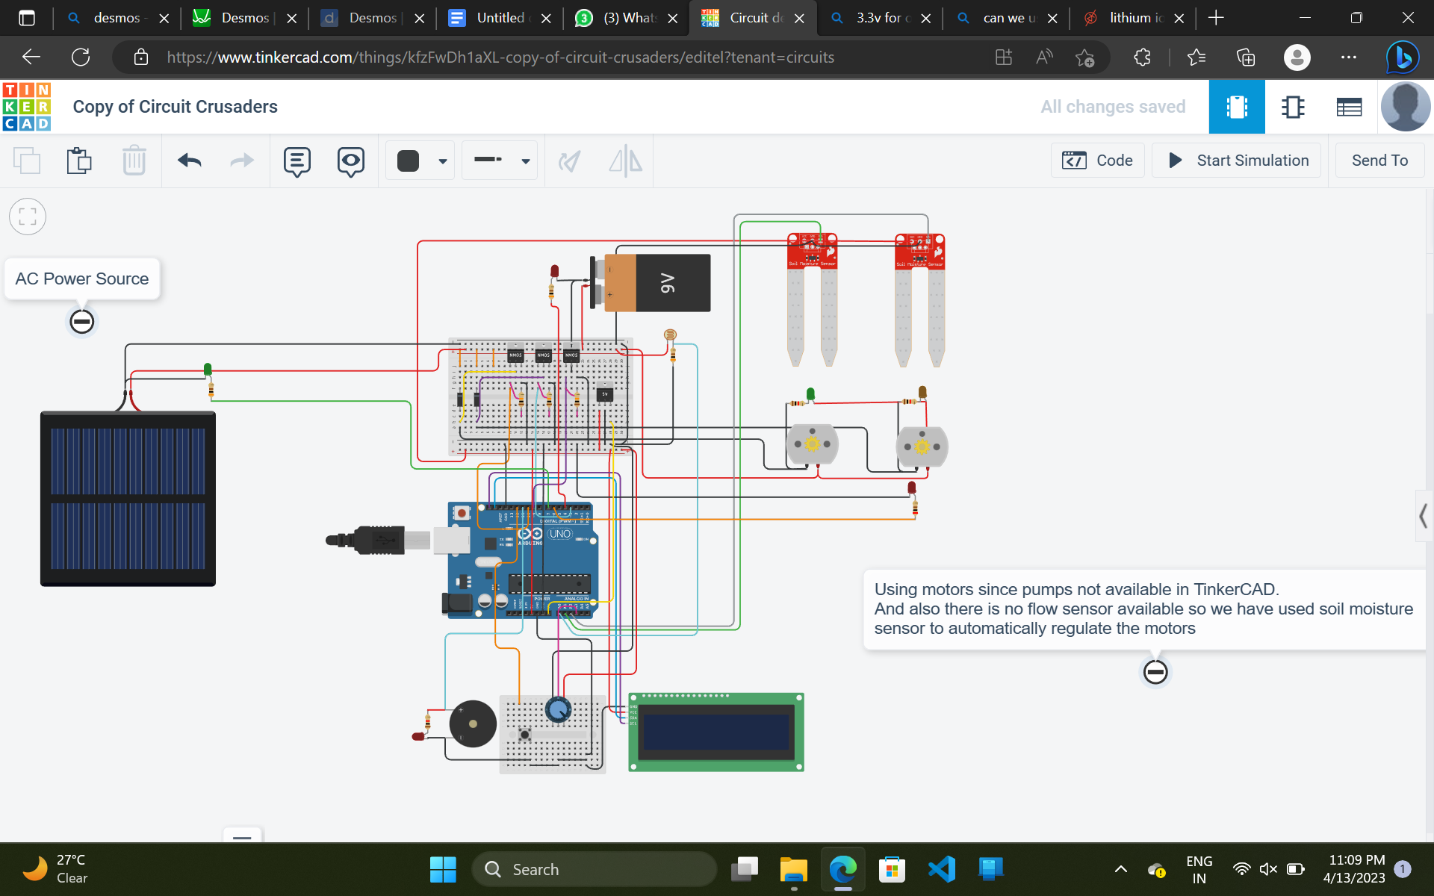

**Expected Results:**

As in [simulation](https://www.tinkercad.com/things/dSf4Sr0fjCA?sharecode=Zc1drCgaHbjBibmzNB9_ajDTjG7SfDqKY42qExFL4sY) and in the [reference](https://www.thingiverse.com/thing:4921885)**.**

**Tools Required:**

| **SL No** | **Tool Name** |
| --- | --- |
| **1** | **USB micro-B Cable - 6 Foot** |
| **2** | **Multimeter** |
| **3** | **3D Printer** |
| **4** | **Screw driver** |
| **5** | **Oscilloscope** |
|  |  |

**BOM (WIP not completed) :**

| **SL No** | **Name** | **QTY** | **PRICE** | **Amount** | **LINK** | **DATASHEET** | **Funding type** |
| --- | --- | --- | --- | --- | --- | --- | --- |
| 1 | | ESP32 - DevKitC | | --- | | 1 | 380 | 380 | <https://www.electronicscomp.com/esp32-development-board-with-wifi-bluetooth-india?search=esp32%20dev&sort=p.price&order=ASC> | <https://www.espressif.com/sites/default/files/documentation/esp32_technical_reference_manual_en.pdf> |  |
| 2 | | Pool Water Pump 240L/H | | --- | | 2 | 250 | 500 | <https://robocraze.com/products/r365-dc-pump> | See Literature review |  |
| 3 | | N-Channel MOSFET 30V 90A  STP90NF03L | | --- | | 2 | 30 | 60 | <https://www.electronicscomp.com/p90nf03l-30v-90a-n-channel-power-mosfet-to-220-package?search=mosfet%20n%20channel%2030v%20> | <https://www.google.com/url?sa=t&rct=j&q=&esrc=s&source=web&cd=&cad=rja&uact=8&ved=2ahUKEwi1_fLTs7b-AhV5rlYBHYRKBfEQFnoECA4QAQ&url=https%3A%2F%2Fwww.st.com%2Fresource%2Fen%2Fdatasheet%2Fstp90nf03l.pdf&usg=AOvVaw2QUirMbiIhKkM2S_Hg0UVP> |  |
| 4 | | Soil Moisture Sensor (Capacitive) | | --- | | 2 | 70 | 140 | <https://www.electronicscomp.com/capacitive-soil-moisture-sensor-v2?search=Soil%20Moisture%20Sensor> | <https://media.digikey.com/pdf/data%20sheets/dfrobot%20pdfs/sen0193_web.pdf> |  |
| 5 | | Transistor - NPN BC337 | | --- | | 2 | 8 | 16 | <https://www.electronicscomp.com/bc337-npn-general-purpose-amplifier-transistor-45v-800ma-to-92-package?search=BC337> | <https://www.onsemi.com/pdf/datasheet/bc337-d.pdf> |  |
| 6 | OLED 1.3 128x64 I2C | 1 | 350 | 350 | <https://www.electronicscomp.com/1.3-inch-i2c-iic-128x64-oled-display-module-4-pin-white?search=oled> | <https://robu.in/wp-content/uploads/2019/12/1.3-Inch-I2C-IIC-OLED-LCD-Module-4pin-with-VCC-GND-Blue-1.pdf> |  |
| 7 | | LED GROW LIGHTS | | --- | | 2 | ? | ? | ? | ? |  |
| 8 | | 10K Ohm Resistor (5PC) | | --- | | 1 | 12 | 12 | <https://www.electronicscomp.com/10k-ohm-2-watt-resistance?search=10K%20Ohm%20Resistor> | - |  |
| 9 | | Rotary Potentiometer - 10k Ohm | | --- | | 1 | 15 | 15 | <https://www.electronicscomp.com/10k-ohm-linear-potentiometer?search=10k%20pot> | - |  |
| 10 | | 100 Ohm Resistor (5PC) | | --- | | 1 | 6 | 6 | <https://www.electronicscomp.com/100-ohm-half-watt-resistance?search=100%20Ohm%20Resistor> | - |  |
| 11 | | Relay SPDT | | --- | | 2 | 30 | 60 | <https://www.electronicscomp.com/5v-10a-pcb-relay?search=Relay%20SPDT%205v> | - |  |
| 12 | | 1K Ohm Resistor (5PC) | | --- | | 1 | 6 | 6 | <https://www.electronicscomp.com/1k-ohm-half-watt-resistance?search=1K%20Ohm%20Resistor> | - |  |
| 13 | | Female DC Power adapter - 2.1mm jack to screw terminal block | | --- | | 1 | 12 | 12 | <https://www.electronicscomp.com/2.1-x-5.5mm-dc-power-jack-socket-female-panel-mount?search=Female%20DC%20Power%202.1> | - |  |
| 14 | LED bulb | 1 | 1 | 1 | - | - |  |
| 15 | | Electrolytic Capacitor - 1uF/50V | | --- | | 1 | 8 | 2 | <https://www.electronicscomp.com/1uf-50v-electrolytic-capacitor?search=1uF%2050V> | - |  |
| 16 | | HeatSink TO-220 | | --- | | 3 | 12 | 36 | <https://www.electronicscomp.com/718-aluminum-heatsink-for-transistor-to-220-package?search=HeatSink%20TO-220> | - |  |
| 17 | | Voltage Regulator 5v  Buck conv | | --- | | 1 | 225 | 225 | <https://www.electronicscomp.com/dc-dc-step-down-buck-converter-power-supply-module-24v-12v-9v-to-5v-5a-25w-replace-lm2596s?search=5v%20buck> | - |  |
| 18 | Push button | 1 | - | - | - | - |  |
| 19 | | Wall Adapter Power Supply - 12VDC 2A | | --- | | 1 | - | - | - | - |  |
| 20 | | BreadBoard | | --- | | 2 |  | - | - | - |  |
| 21 | | Capacitor Ceramic 100nF | | --- | | 1 | - | - | - | - |  |
| 22 | | Jumper Wires Pack - M/M | | --- | | - | - | - | - | - |  |
| 23 | | Jumper Wires Pack - M/F | | --- | | - | - | - | - | - |  |
| 24 | Tube | 1M | 350/M | 350 | - | - |  |
| 25 | PerfBoard (Railed) | 2 | 40 | 80 | - | - |  |
| - | | **Total** | | --- | |  | | 33 | - | 2251+ | - | - |  |